Chapter2: Libraries installation

2.1 Required library introduction

2.2 Installation in Linux system

2.2.1 Numpy

2.2.2 Pillow

2.2.3 Matplotlib

2.2.4 SimpleITK

2.2.5 VTK

2.3 Installation in Windows system

2.3.1 Numpy

2.3.2 Pillow

2.3.3 Matplotlib

2.3.4 SimpleITK

2.3.5 VTK

2.4 Installation of pymesh

2.5 Summary

Chapter2: Libraries installation

2.1 Required library introduction

Before learning to use the library, there are some preparations to be completed to ensure the correct use of the library. First of all, the library was written in Python 3. To ensure that the code works correctly, please use Python 3. Since the library is designed to help users process medical images easilier rather than create new ways to process them, we've written with reference to some existing open source libraries, so you need to make sure that you install those libraries on your computer before using them, including: Numpy, Pillow, Matplotlib SimpleITK, VTK, pymesh.

Among them, Numpy, Pillow, Matplotlib are more basic and common Python function libraries, which will not be described in detail in the next introduction, while SimpleITK, VTK, which are more focused on medical image processing, and pymesh, which is used in surface processing library, will focus on explanation.

In addition, since ways of installing libraries in OS X system are similar to those in Linux, they will no longer be explained separately.

2.2 Installation in Linux system

2.2.1 Numpy

First of all, for Linux users, PIP installation is relatively simple, installation package version is relatively new, is a more concise way to install.

This operation requires only one line of code:

1. 1.  sudo pip install numpy

Second, you can download the source code to install on the official website：

1. wget https://sourceforge.net/projects/numpy/files/latest/download

Decompression source package：

1. unzip numpy-1.9.0.zip

Enter decompress directory：

1. cd numpy-1.9.0

Run the setup.py file in the decompressed directory:

1. python setup.py install

2.2.2 Pillow

The library can also be installed directly with PIP：

1. sudo pip install pillow== version number

Or you can try:

1. sudo pip install -I --no-cache-dir -v Pillow

2.2.3 Matplotlib

Similarly, PIP installation is still feasible：

1. sudo pip install matplotlib

Or you can try to download the source installation package and install it as we introduced in 2.2.1,

Source download website：<https://sourceforge.net/projects/matplotlib/files/matplotlib/>。

Later versions of Python's installation of Matplotlib may require some dependency libraries, which can be solved by referring to the following code：

1. sudo apt-get install libfreetype6-dev g++

2.2.4 SimpleITK

The installation of SimpleITK under Linux is very simple. Even the official website recommends PIP installation. The code is as follows：

1. sudo pip install SimpleITK

You can also use some software to build the environment, such as Anaconda and so on. 2.2.5 VTK

The simple installation method is to use PIP and other non-compilation installation. The code is as follows：

1. sudo pip install vtk

or：

1. sudo apt-get install python-vtk

The above two ways will achieve the same effect.

If you already have a good foundation of cmake etc. on your computer, VTK installation can also be compiled and installed using basic software such as g++ or cmake. Take cmake as an example：

First download VTK：<http://www.vtk.org/download/>；

Unzip the file to the path you want：

1. sudo unzip VTK-7.0.0.zip

Preparing compiled file directory：

1. mkdir VTK_BULD
2. cd VTK_BULD
3. ccmake ../VTK/VTK-7.0.0

implement make

1. sudo make

Install：

1. sudo make install

2.3 Installation in Windows system

2.3.1 Numpy

In Windows system, PIP installation is also a very simple method：

1. pip install numpy

*.whl file download installation is also feasible, but it is more troublesome than PIP installation：

Download Numpy：<https://www.lfd.uci.edu/~gohlke/pythonlibs/#numpy>

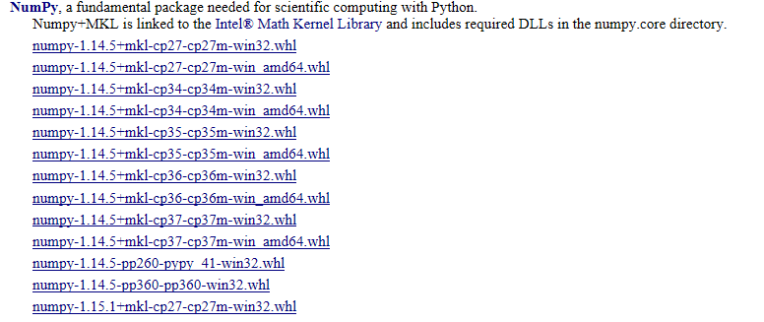

Select the appropriate version to download and use the cd command to open the download directory at the command line window, and enter the code：

1. pip install filename .whl

The command line window will give hints after installation is completed.

2.3.2 Pillow

PIP installation：

1. pip install pillow

Or the same as Numpy, download the *.whl file to install, download website:

<https://www.lfd.uci.edu/~gohlke/pythonlibs/#pillow>

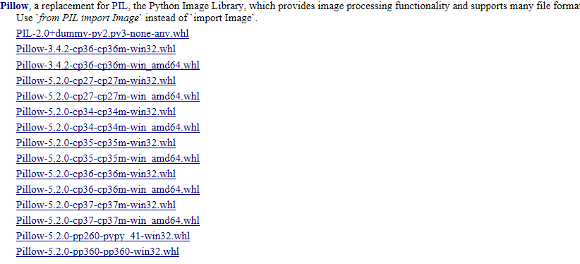

The rest of the operations are the same as installing Numpy.

2.3.3 Matplotlib

PIP installation：

1. pip install matplotlib

Like Numpy, Matplotlib can download *.whl files . Download website:

<https://www.lfd.uci.edu/~gohlke/pythonlibs/#matplotlib>

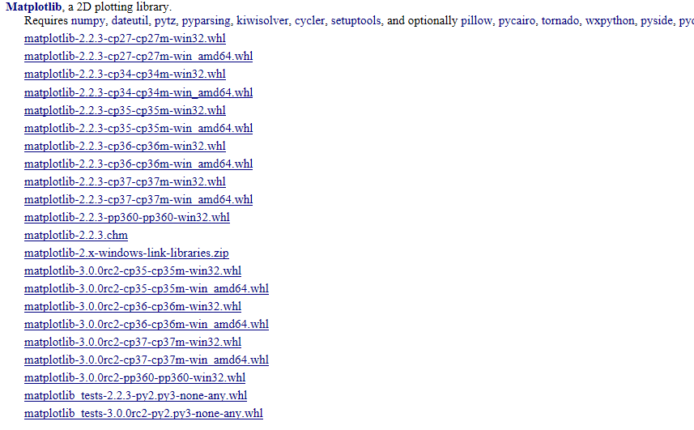

The rest of the operations are the same as installing Numpy.

2.3.4 SimpleITK

PIP installation：

1. pip install SimpleITK

or：

1. python -m pip install SimpleITK

Or go to the official website to download *.whl files：

<http://www.simpleitk.org/SimpleITK/resources/software.html>

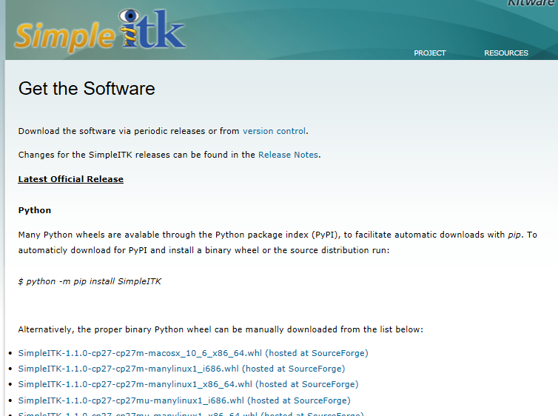

Then install the same steps as installing Numpy.。

2.3.5 VTK

PIP installation：

1. pip install vtk

*.whl file download & installation：

<https://www.lfd.uci.edu/~gohlke/pythonlibs/#vtk>

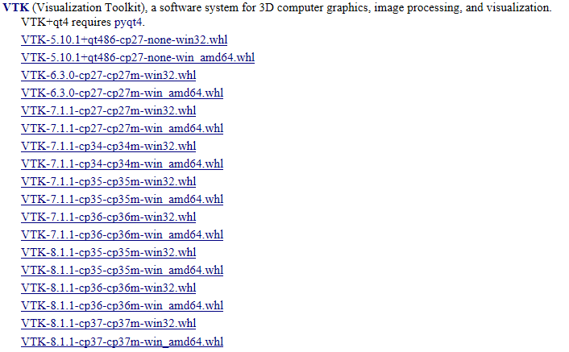

Then enter the download directory, start the command line window, enter the command：

1. pip install 文件名

Complete installation.

2.4 Installation of pymesh

The creator has already explained in more detail in the manual, and there is no other specially optimized installation method for now. Here is the site of the installation introduction:

https://pymesh.readthedocs.io/en/latest/installation.htmlThe installation can be completed according to the guidance method.。

2.5 Summary

The above is the installation method of the medical image processing dependency library, of course, there are many different means to achieve installation, not all listed, the above is a more common means. In addition, after you install successfully, don't forget to import various libraries in Python to make sure they can be used, so as not to cause errors when using this library function.